|  |
| --- |
| **National University of Computer and Emerging Sciences** |
| In Lab Exercise 4  “Data Retrieval Select-from-where Join Order by” |
|  |
| Database Systems |
| Spring 2018 |

Department of Computer Science

FAST-NU, Lahore, Pakistan

# Exercise

For this exercise use the following schema, the script to create this schema and populate data is given in ATM.SQL file

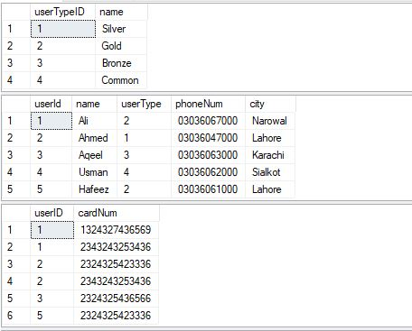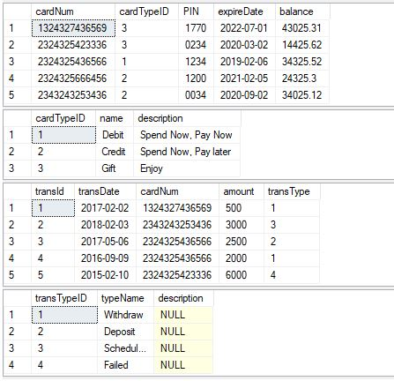

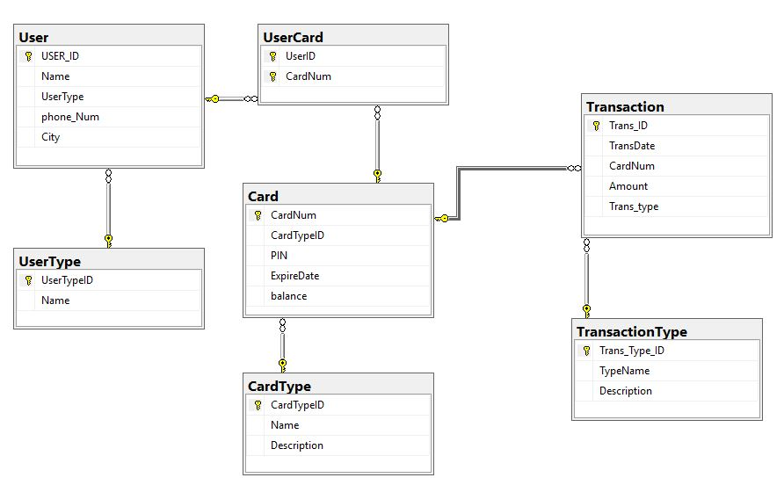

1. List all names of the users from Lahore in Descending Order.
2. List all cards, who have card type “Credit” in ascending order.
3. List the **name** of all the users who are **Gold** type.
4. List the names of the user who’s Card number ends with 6. (**HINT:** USE LIKE)
5. List the Cities of the users who have balance between 20000 and 35000.
6. List the Users who have never used the Card for transaction.
7. List the Card numbers that will expire in year 2020.
8. List the names of the users who’s transaction had failed.
9. List all the card numbers with owner names and scheduled transactions, in case the user has never used scheduled transaction show null or zero in the transaction column. (Hint use ISNULL function)
10. List all usernames and phone number, who’s card number expiry date is less that 2-2-2019.
11. List all users ID’s , Name and card numbers who have committed transactions today.